EXERCISE 8
- How many unique salary packages does our company, Bignet offer? List them in descending order.
There are total of 9 unique salary packages that Bignet company offer.
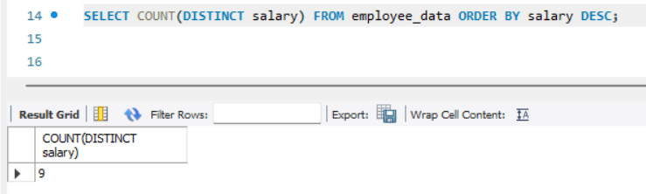

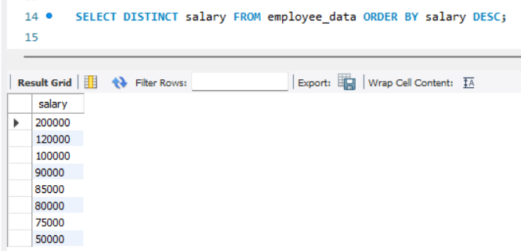

- How many distinct first names do we have in our database?
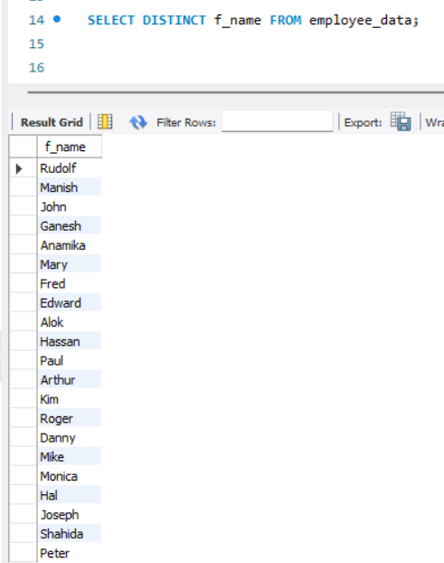
There are total of 21 distinct first names in the database.
